**Event Manager**

**Abstract**

Event manager is a web application for which the basic idea is that various users over the net can book for various events that are posted on this “event manager” website.

There are 3 actors for this website. They are:

1. Admin

2. Event organizer

3. End User or Participant

Functions of Admin :

1. He has the rights to allow any event in the web application. Every event gets approved by the admin before being posted in the application.
2. He also has the right to add the places where events can take place.

Functions of Event organizer :

1. The event organizer has the rights to post any event on the website.

Functions of End User :

1. He has the rights to browse through the website to view all the events posted by various event organizers.
2. Only the registered users can books tickets for an event

**WebPages with functionalities in the application**

Page1:

1. This page populates all the events in the database.
2. This page contains links to login page and also registration page.
3. The page after login page is of 3 types i.e different for 3 types of user

Page2:

For End User

1. This page populates all the events in the database based on the city preferences on the top of the page.
2. This page contains history of his previous events he visited.

For Event Organizer

1. This page contains events he had created buttons below each event to get an approval if the event date is greater that today’s date.
2. This page contains history of his previous events he had created.
3. This page also contains a link to a page where the event organizer can create an event and ask for approval as well.

For Admin

1. This page populates all the events in the database with their approval status and hence the admin can update the status on clicking on the approve button below each and every event then and there itself.
2. This page contains link to another page where he can add venues based on the city state and country.

**Use Case Diagram**

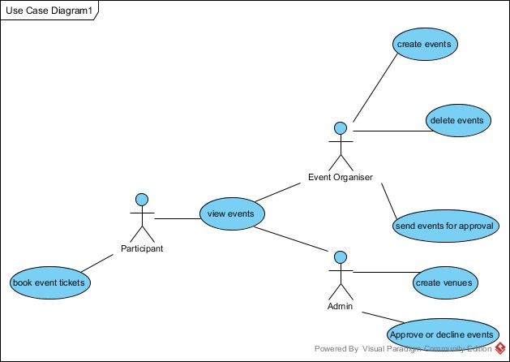

|  |  |  |
| --- | --- | --- |
| S.NO | ACTOR | FUNCTIONALITY |
| 1 | Admin | 1. Approves or declines events 2. Creates Venues |
| 2 | Participant | 1. Book Event Tickets |
| 3 | Event Organizer | 1. Create events 2. Delete events 3. Send events for approval |

Screenshots of MakeMyEvent :

Home (For Guest User):

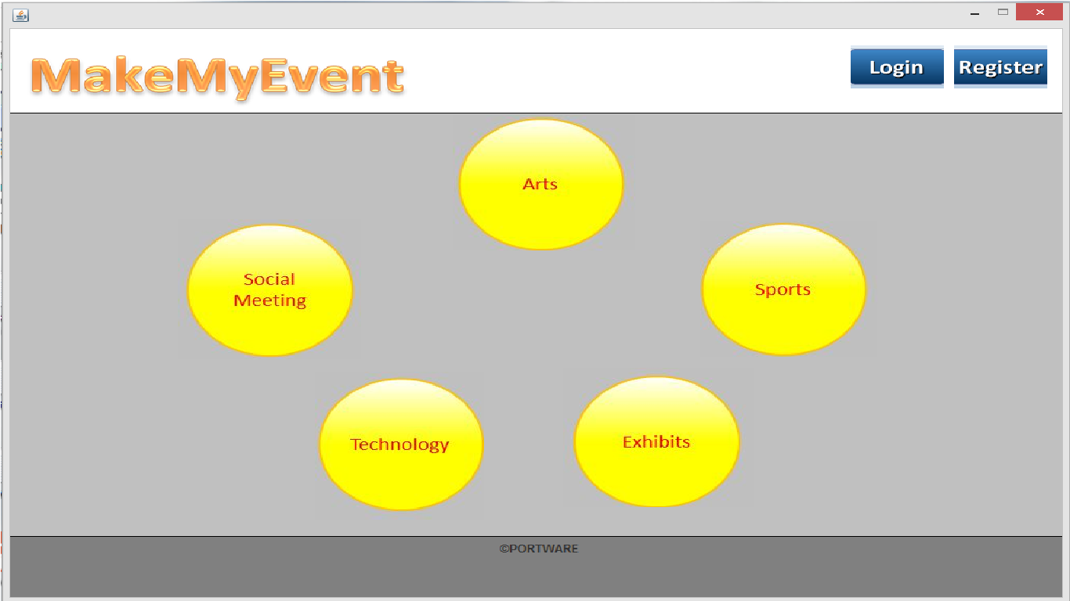

When a guest user enters into the application MakeMyEvent, She/he gets the above page as his/her home page.

Events:

When we click on any of the bubbles in the home page, we get the events listed as follows

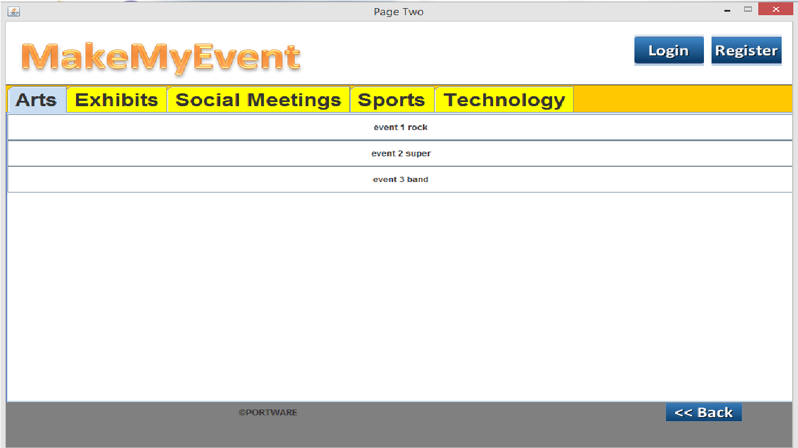

Events Description:

Once an event is clicked, We are transferred to another page where this event is described.

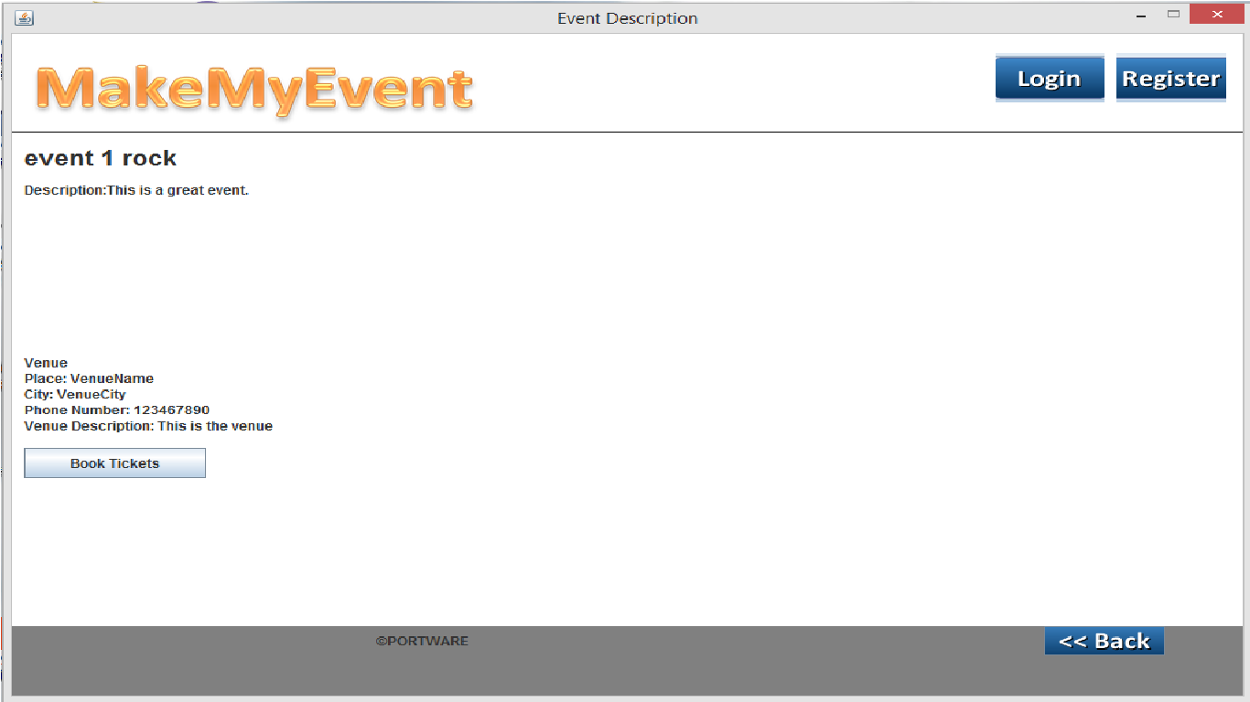

Though events can’t be booked for guest user. He will be redirected to the login page in order to ask the guest user to login into his/her account.

Login :

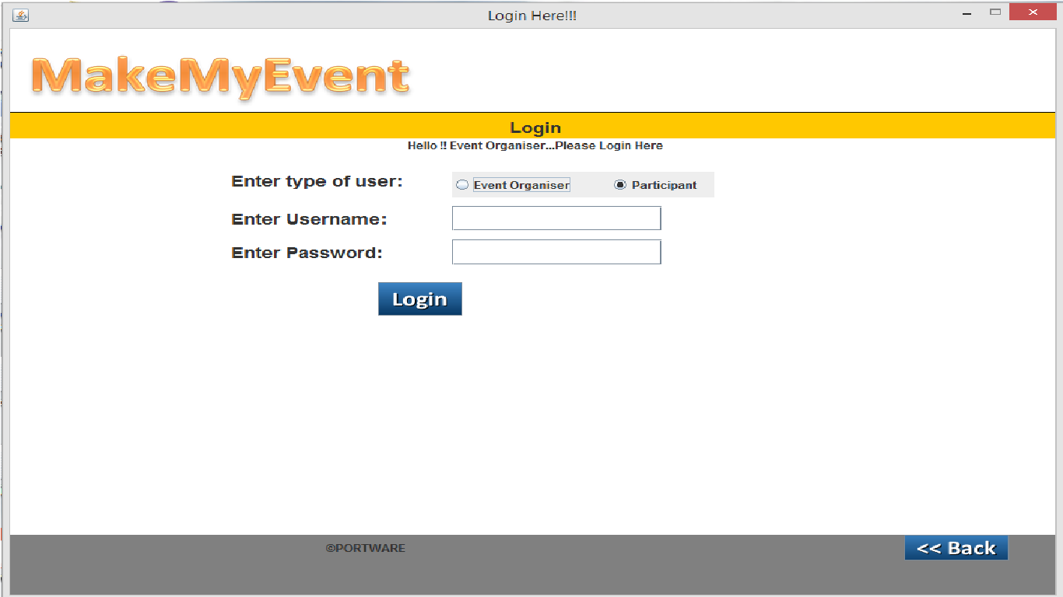

If credentials don’t match it gives an error popup as follows:

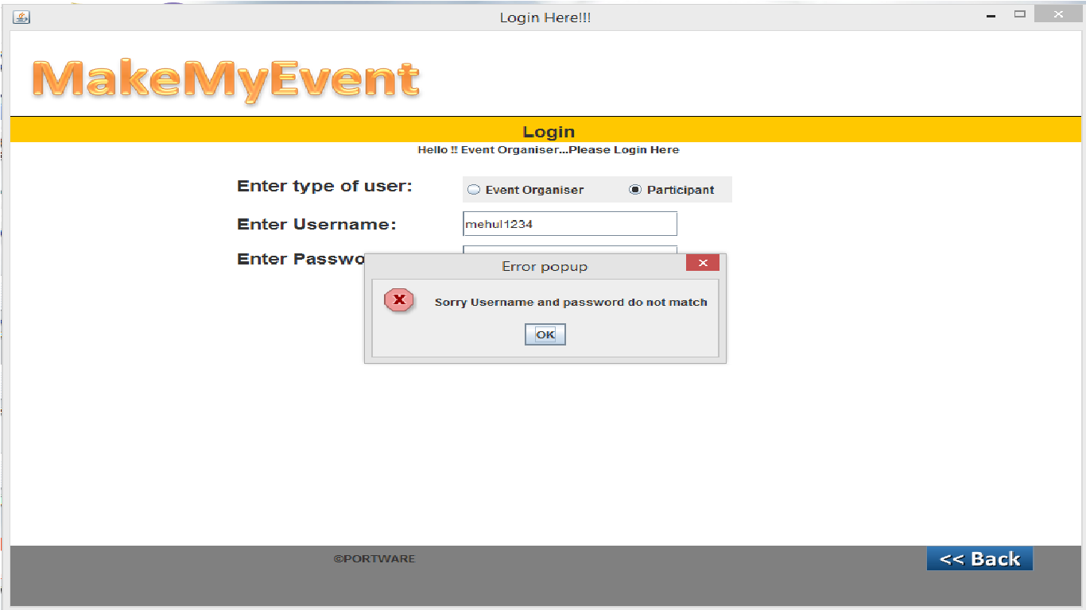

Register :

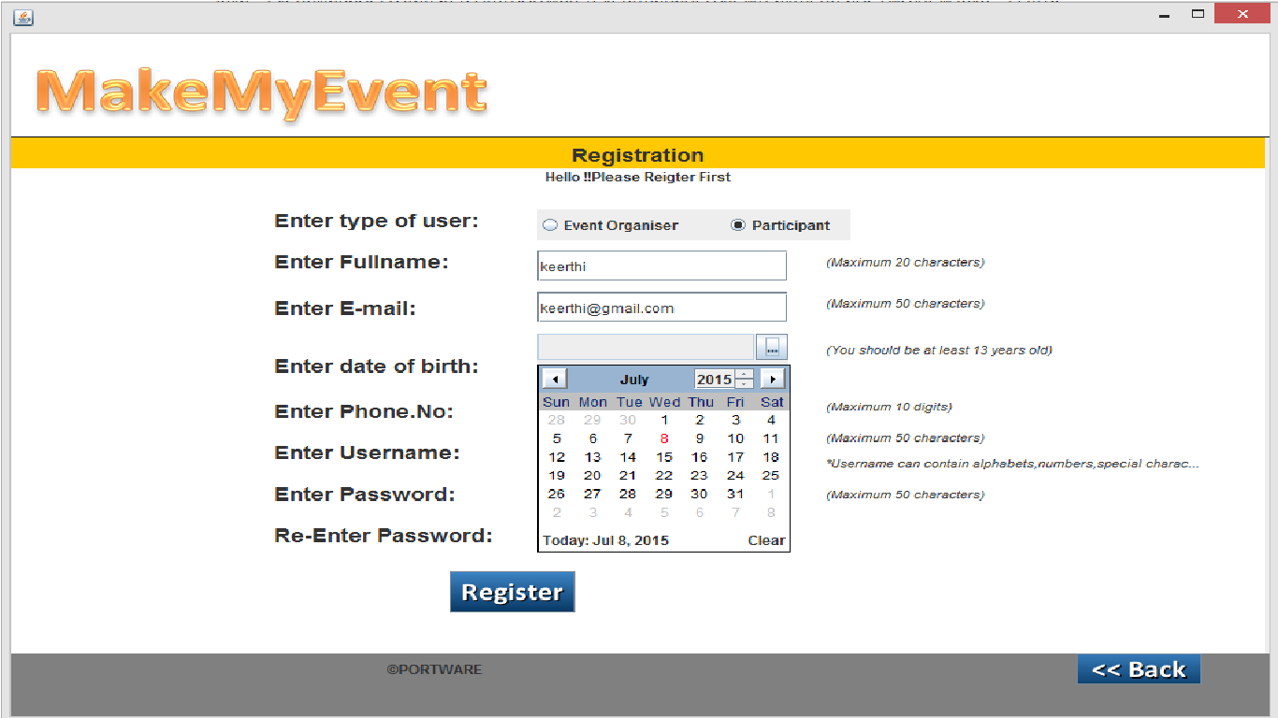

After the registration is done successfully ,The participant is redirected to login page showing a status of his registration

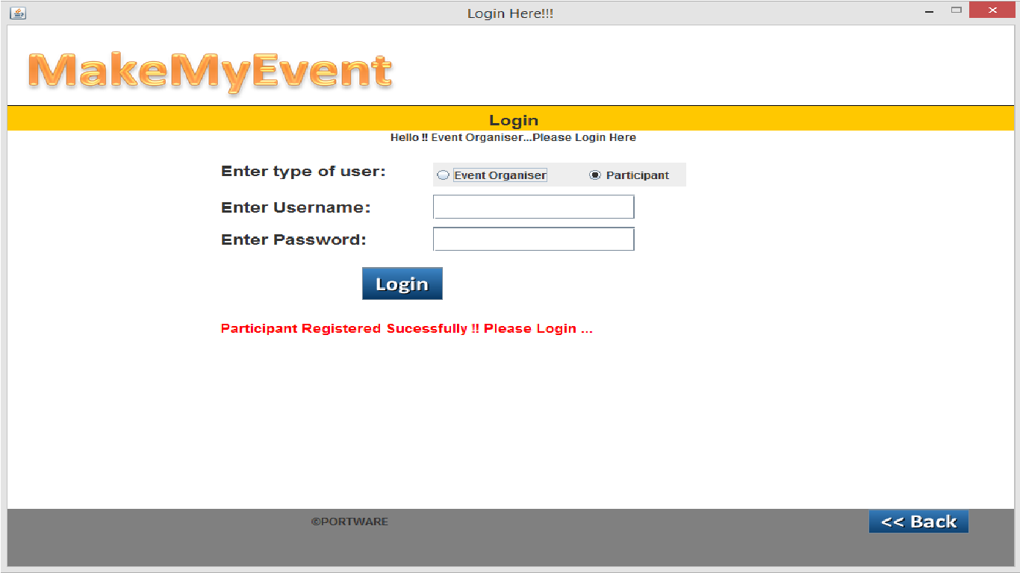

Participant’s Booking Events :

The participant is directed to his home page where he can find all the events as follows :

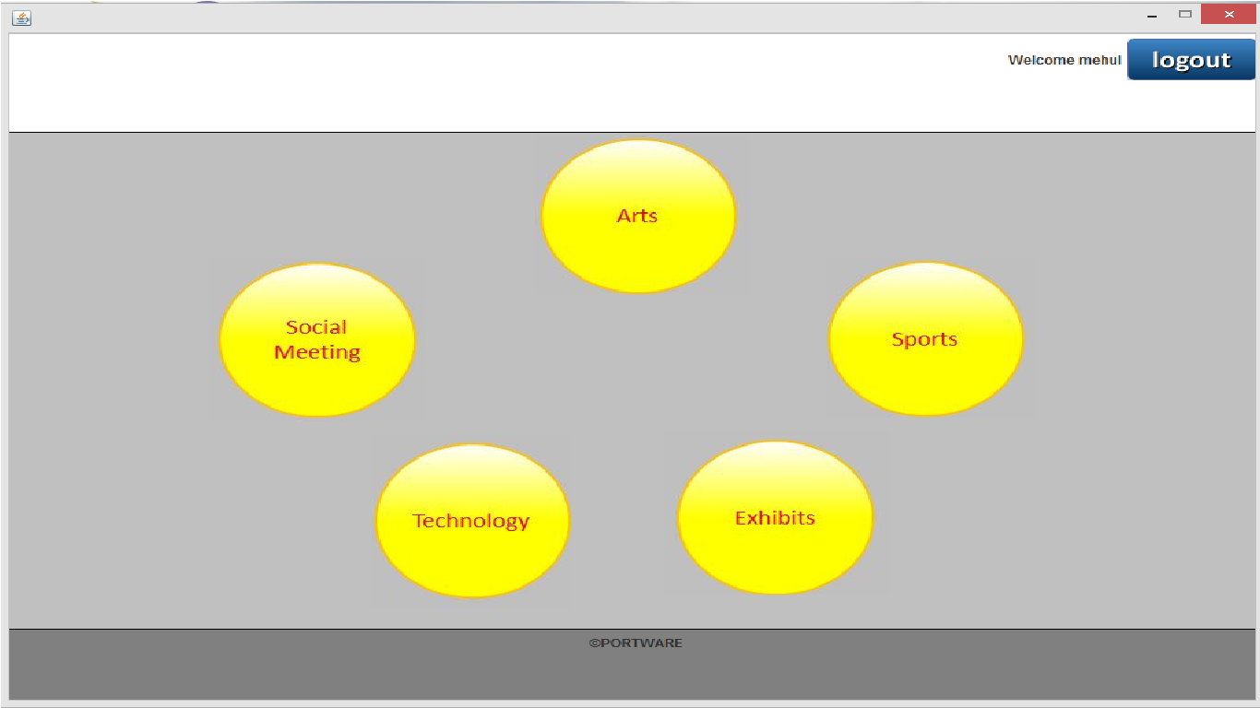

He/She can browse through the events by clicking on the event categories. All the events in that particular event get listed as follows: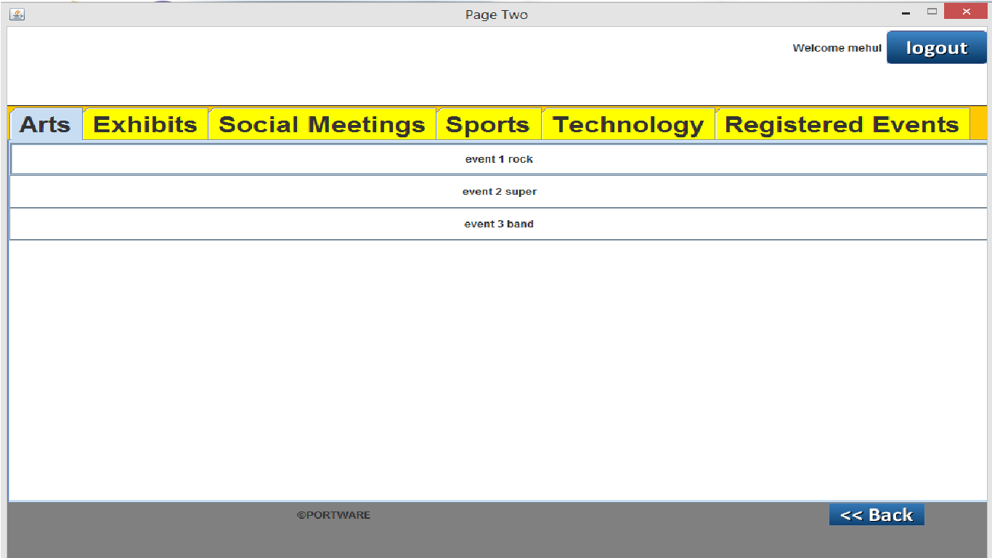

He /She can book tickets by clicking on the button “book tickets” 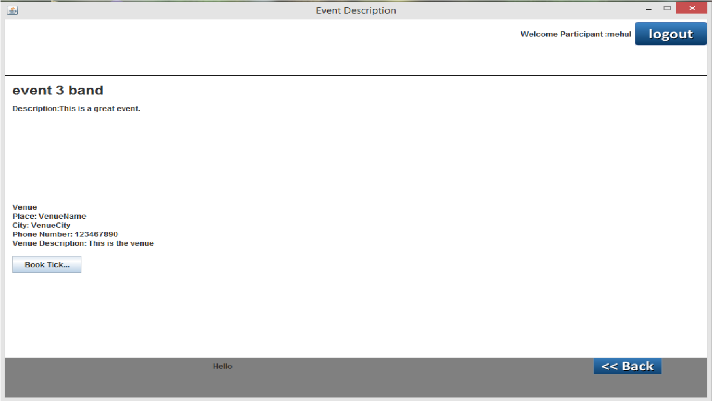

Later he is redirected to a page where he can select number of seats for the events If there is availability